
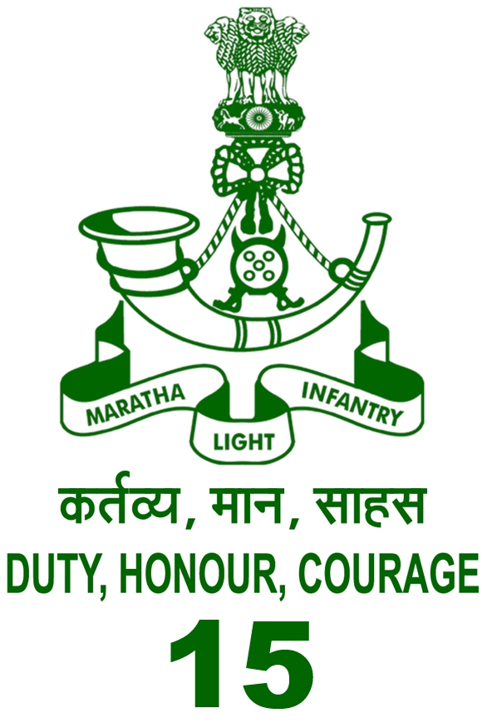
Best wishes to
Harpartap & Jappita
on their marriage

From
CO & All Ranks of ‘Burj’ Battalion

COMMANDING OFFICER

